**SOLITAIRE**



**Session 2023 – 2027**

**Submitted by:**

Amna Atiq 2023-CS-83

**Supervised by:**

Sir Nazeef ul Haq

**Course:**

CSC200 - Data Structures & Algorithms

Department of Computer Science

**University of Engineering and Technology Lahore Pakistan**

Table of Contents:

1. Introduction 3

2. Objectives 3

3. Project Requirements 3

4. Implementation Details 3

5. Features and Functionality 3

6. Testing and Test Cases 3

7. Results 3

8. DSA implementation: 4

9. Conclusion 4

10. Wireframes: 4

**Table of Figures:**

Figure 1 4

Figure 2 5

Figure 3 6

Figure 4 6

# 1. Introduction

This is Solitaire Klondike, an implementation of the well-known card game in Python. It uses data structures and algorithms for its logic and Pygame in its graphical user-interface. The skills here involved are the development of GUI applications, oop, and data structure..

# 2. Objectives

The objectives of this project are:

* Develop Solitaire game under Klondike rules.
* Implement and use stacks, queues, linked lists, and arrays.
* Provide an interactive user experience using drag-and-drop functionality of cards.
* Reinforce data structures through actual application.

# 3. Project Requirements

* **Python 3.8+**
* **Pygame**
* **Pillow (PIL)**

# 4. Implementation Details

**Data Structures:** Below are some of data structures used in the game:

* + - **Stacks:** Foundation piles and tableau piles.
    - **Queues:** For stock pile and waste pile.
    - **Lists:** For the card deck and tableau formation.
    - **Linked Lists:** Used for flexibility in card formation and manipulation.

**Game Logic:**

* + - **Card Movement Rules:** Include when employing Klondike Solitaire rules, which require foundation sequence from Ace to King and ordering of the tableau in alternate colors and descending order from King to Ace
    - **Win Detection:** A condition checks if all foundation piles have full sequence from Ace to King for each suit.
    - **Drag-and-Drop Interaction:** It enables intuitive movement of cards across piles using mouse events.

# 5. Features and Functionality

* 1. **Solitaire Rules:** Klondike card game rules fully implemented
  2. **Graphical User Interface :** Developed using pygame It has a simple drag-and-drop functionality.
  3. **Undo Move:** The ability to undo the last move.
  4. **Stockpile and Waste Pile:** Cards are drawn from the stockpile and moved to the waste pile for play.
  5. **Win Condition:** The game detects winning conditions when all foundation piles filled.

# 6. Testing and Test Cases

Following are number of test cases created to make sure the following are true:

* + **Correct Card Movement:** Cards are moved correctly into tableau, stockpile, and foundation piles
  + **Legal Move Enforcement:** Illegal moves are refused and cards may only be moved under legal rules
  + **Win Condition:** The game correctly detects a win upon filling all foundation piles.
  + **Undo Functionality:** Moves can be undone and redone to test robustness.

# 7. Results

* + Smooth gameplay.
  + Win detection and rules enforcement are correct
  + Interactive interactions ensure a fun gameplay

# 8. DSA implementation:

1. Stacks: In Solitaire, stacks are the building blocks of arranging and shifting cards both on the tableau where cards have been placed face-down or face-up and the foundation piles where ordered cards are placed to win the game. Any column in a tableau as well as every pile in the foundation is realized as a stack. The last-in-first-out property of stacks makes them suitable for adding cards (push) to a column or foundation piles and drew cards (pop) to move them between columns, to foundation piles, or to the waste pile.

2. Queues: They are present in the draw pile in Solitaire. Cards drawn from the deck are drawn sequentially. Queues are excellent for handling the sequence of appearance of cards because they support the first-in-first-out property of queues: Cards are put into the queue every time they are dealt. It is the original draw pile and players draw cards from the deck in order to expose and play them, so that the oldest card turns up first in the waste pile.

3. Arrays/Lists: An list contains the complete deck for shuffling and preliminary distribution. A 2D list stores cards by tableau column. Lists are used to shuffle cards randomly for the game. List index-based access to get individual card and appending and removing the cards when tracking changes in the deck, in the draw pile, as well as the waste pile.

# 9. Conclusion

This project offered a great learning experience in implementing the data structures and algorithms within a GUI framework. The full-featured Solitaire game developed was an excellent example of the very straightforward use of stacks, queues, and lists in the management of complex game state and logic. An interesting, aesthetic game that functions by traditional rules of Solitaire is successfully developed in this project

# 10. Wireframes:

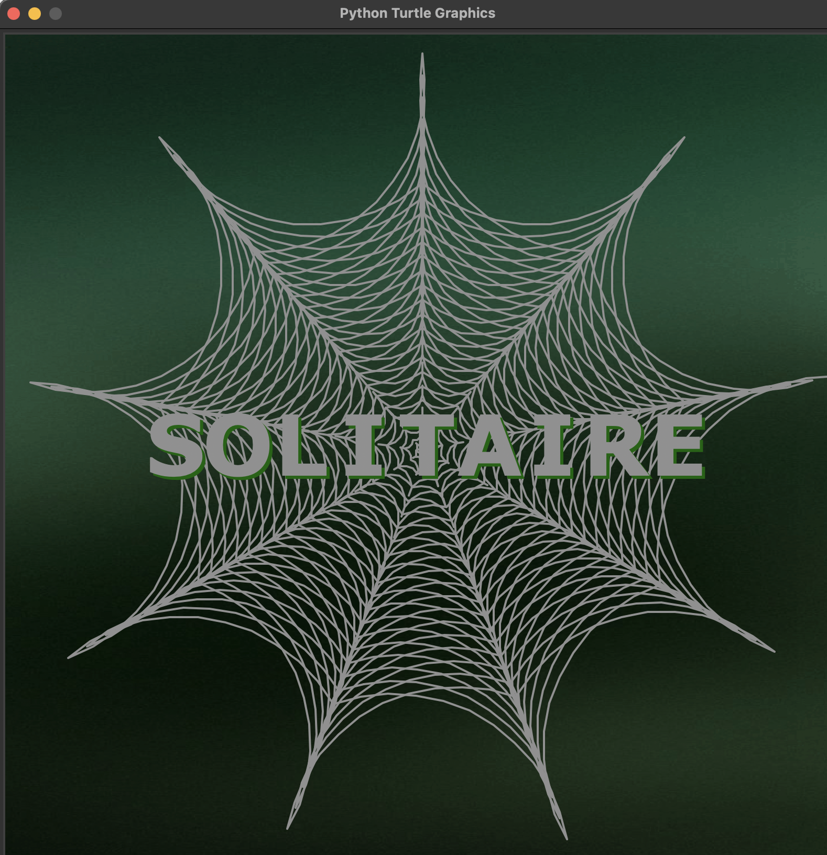

Figure 1

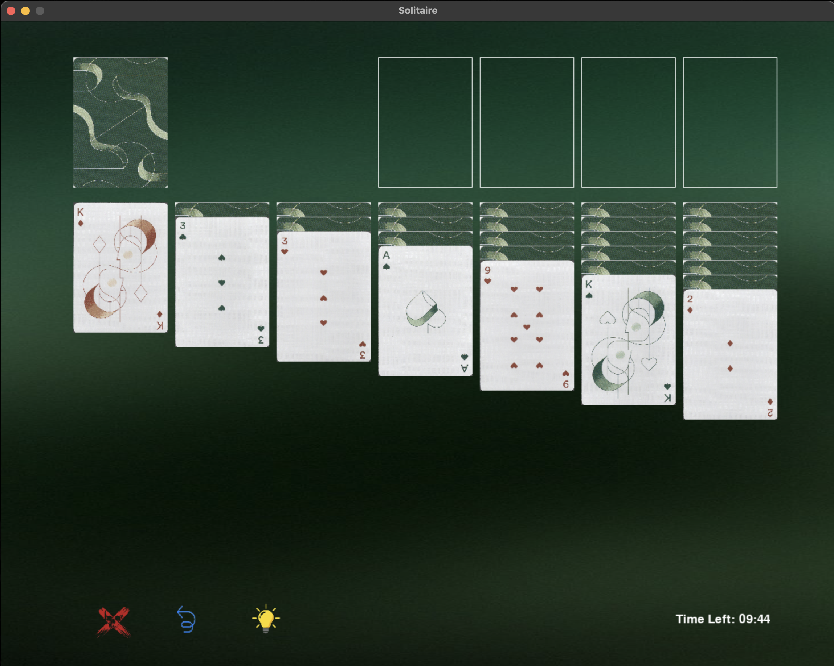

Figure 2

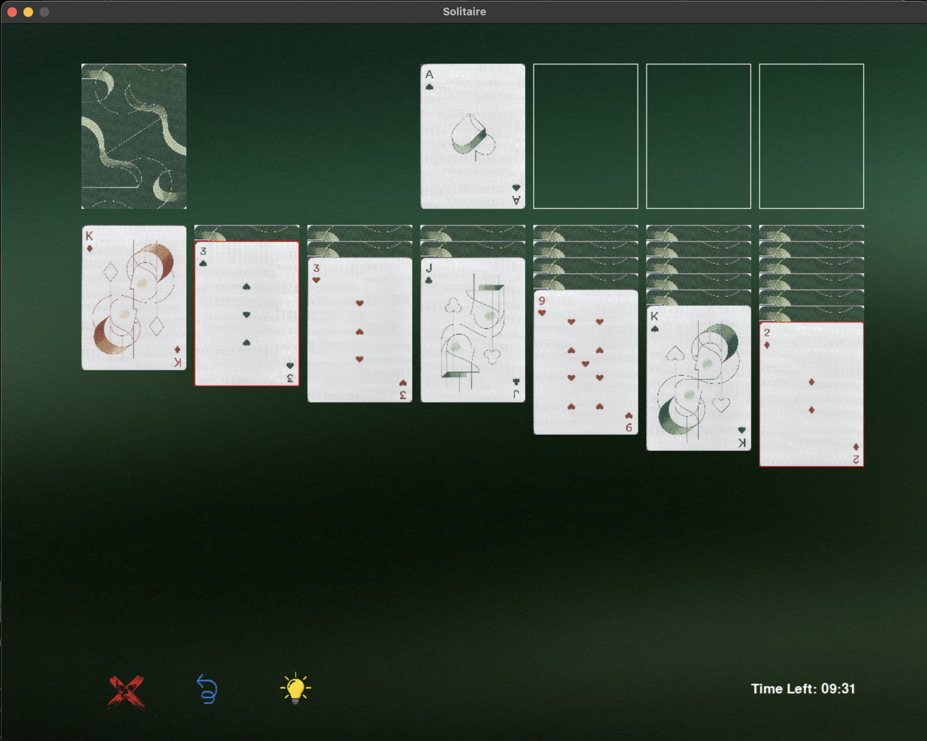

Figure 3

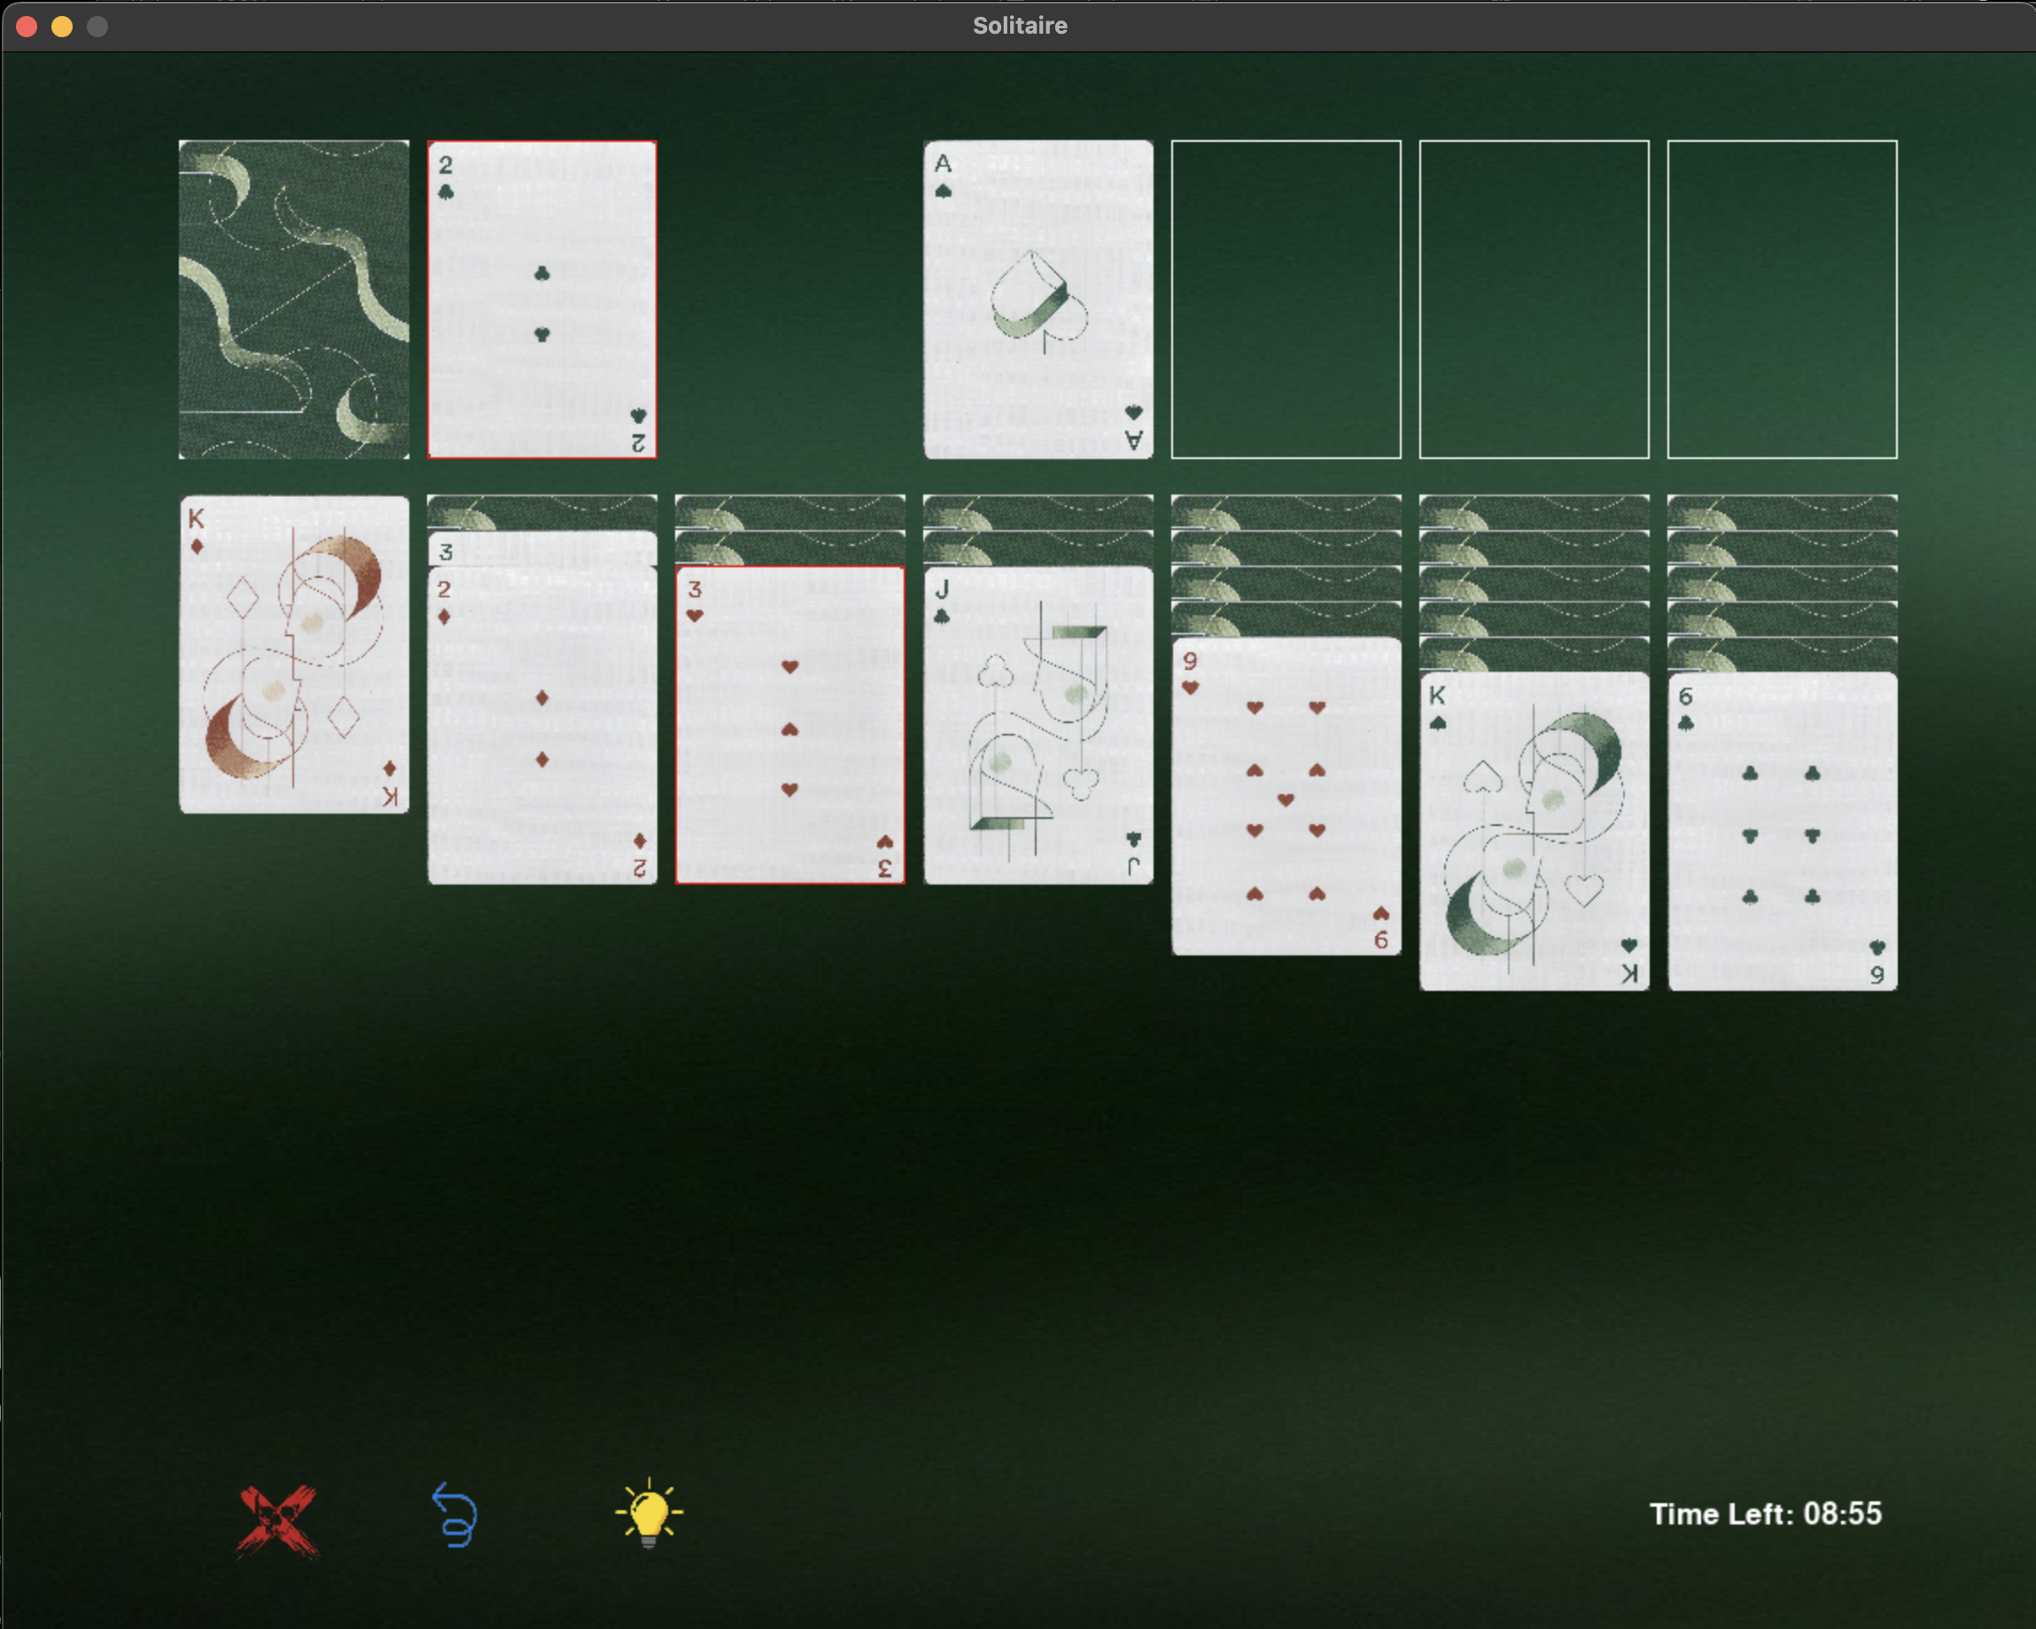

Figure 4